7-1 Final Project Reflection

Robert Rossman
Global Campus, Southern New Hampshire University
CS-330: Comp Graphic and Visualization
Instructor Eugenio Rodriguez
December 14, 2025

For my project, I recreated the notable objects in the following scene:
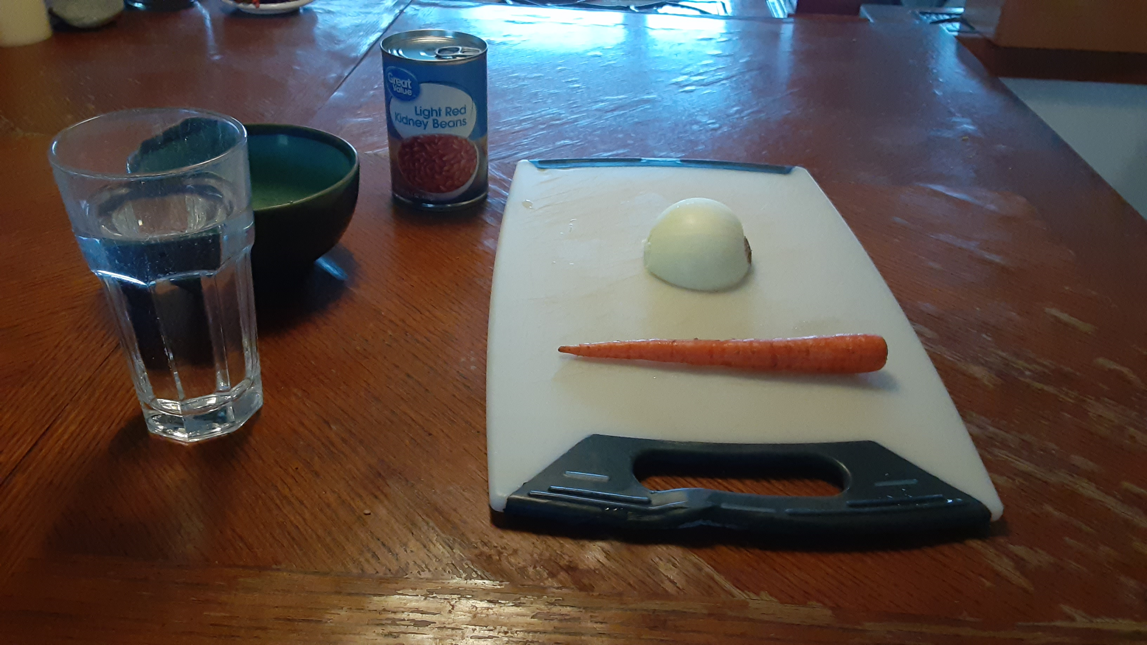
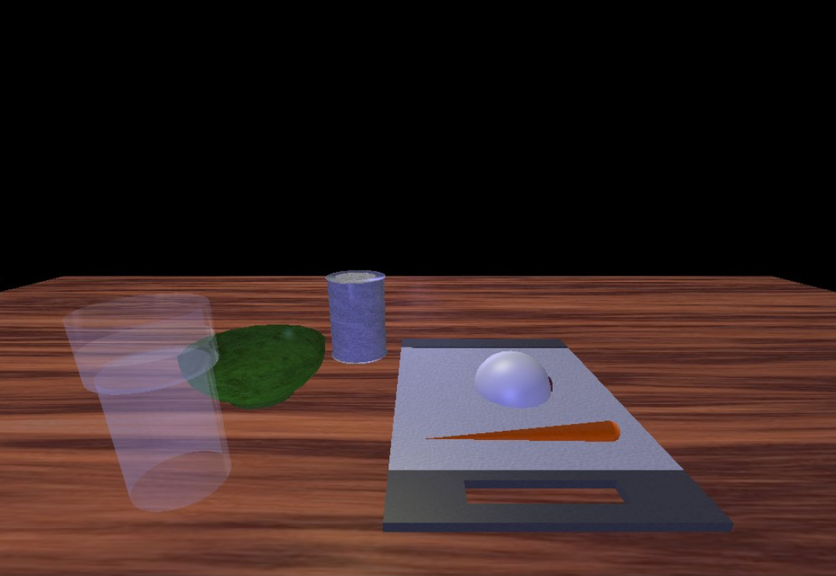
Development Choices
I chose the selected objects in my scene because some seemed fairly simple to render while others had interesting geometry that would be a fun challenge to replicate. For example, very little work needed to be done to recreate the halved onion, as the object is mostly a hemisphere already. The bowl is an example of one of the more accurately recreated objects object as, despite being slightly more complex, the different shapes making it up could still be easily picked out.
Despite the objects being chosen partially due to their apparent simplicity, I still simplified several aspects of the scene. One of the biggest losses for me was making the decision to simplify the octagonal prism base of the glass into a simpler cylinder. Since an octagonal prism was not one of the included simple 3D shapes, it would need to be built out of other shapes. At first I was hoping to use a cylinder with reduced vertices to achieve this, but after some trial and error positioning the vertices of a cylinder mesh in ShapeMeshes.cpp, I concluded that this was outside of the scope of this project. The next thing I tried was to rotate eight pyramids so that they would fit together in an octagonal pattern. Aside from it being difficult to calculate the right rotations and positions for the eight rectangles, this method would also leave visible seams between the pyramids since the glass is semitransparent. In the end, I simplified the object by instead using two semitransparent cylinders to represent the water in the glass, and then one more transparent cylinder to represent the top of the glass.
Other notable simplifications can be seen in the cutting board and the can objects. For the cutting board, the issue came from trying to emulate the trapezoidal shapes at its edges and its elliptical handle. Lacking an easy method of making flat triangles and rounded cut-outs, I opted to simply make the ends and the handle of the board square. For the can, the simplification was to remove the label on the can that was present in the original scene. This was largely done to avoid issues with a label texture wrapping improperly, but it also has the added bonus of making the can more reflective.
Navigation
The navigation in my 3D scene uses both mouse and keyboard inputs. Moving the mouse controls the angle of the camera in the scene, while the scroll wheel increases the speed of the camera movement. The keyboard has inputs that move the camera including the W, A, S, and D keys for forward, left, right, and backward movement, and the Q and E keys for upward and downward movement. Also included are the O key to switch the camera to an orthographic view and the P key to reset the camera’s position and return it to a perspective view.
Custom Functions
The primary practice I engaged in to make my code more organized was to leave comments explaining the function of code blocks. However, I also made my code more modular by breaking up its logic into multiple functions. One example of this was adding a “ResetCameraPosition” function to both position the camera when first starting the scene and to set the camera’s position when switching back to the perspective view with the P key. This allowed the code to be reusable and ensured any desired changes to the default positioning of the camera would only need to be made in one place.
Another example of making my code more modular came from me splitting the rendering of each object into its own function. This helped keep the “RenderScene” function concise and made it clearer where the code for each object was kept. In Visual Studio, putting code in separate functions like this also allows it to be collapsed, making the rest of the code more readable.

